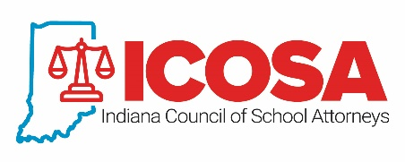

INDIANA COUNCIL OF SCHOOL ATTORNEYS

2023-2024

APPLICATION FOR

MEMBERSHIP

Attorneys who represent on a regular or continuing basis a school corporation or educational entity that is a member of the ISBA and who are licensed to practice and are in good standing with the Indiana Bar are eligible to join ICOSA. Attorneys must also maintain membership in at least one national school attorney organization, the National School Boards Association Council of School Attorneys (COSA) or the National School Attorneys Association (NSAA).

To qualify for membership in ICOSA for the 2023-2024 fiscal year, please complete this application and return it to Casey Conrad, ISBA Administrative Assistant, at cconrad@isba-ind.org. Remittance of membership dues for one of the national school attorney organizations and ICOSA must be made by September 22, 2023.

Please type or print
(Attorney Name) | (Law Firm Name)
(Street Address)
(City) | (State) | (Zip)
(Business Phone) | (Email Address)

I, ______________________, state that I provide legal services to the following school corporation(s):

______________________________________________
______________________________________________
The above statement must be certified by the superintendent or board president of one of the
school corporations listed above.

I, ______________________________, certify that ________________________ provides legal services to the ________________________ School Corporation.

_______________________________ ______________________
Superintendent/President Signature Date
In addition to membership in ICOSA, I elect to be a member of:
COSA Affiliate (private practitioner)
COSA In-House
NSAA
COSA Affiliate (private practitioner) & NSAA
COSA In-House & NSAA

_______________________________ __________________________
Attorney Signature Date

