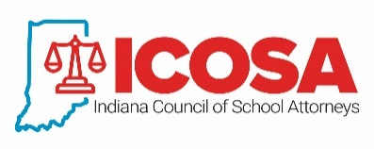

INDIANA COUNCIL OF SCHOOL ATTORNEYS

2021-2022

APPLICATION FOR MEMBERSHIP

The Indiana School Boards Association (ISBA) approved the creation of the Indiana Council of School Attorneys (ICOSA) and its affiliation with the National School Boards Association’s Council of School Attorneys (COSA) in 2016. Because of the affiliation with the national COSA, in order to be a member of COSA, an attorney must also be a member of ICOSA. Members of both Councils will be eligible to attend COSA seminars and receive COSA resources at a reduced rate and to participate in ICOSA meetings and activities.

Attorneys who represent on a regular or continuing basis a school corporation or educational entity that is a member of the ISBA and who are licensed to practice and are in good standing with the Bar of Indiana are eligible to apply for membership in ICOSA. To qualify for membership, an attorney must complete this application and submit the approved dues of both COSA and ICOSA. The membership period for both organizations will be July 1, 2021 – June 30, 2022.

Please type or print
(Attorney Name) | (Law Firm Name)
(Street Address)
(City) | (State) | (Zip)
(Business Phone) | (Fax)
(Email Address)

I, ______________________, state that I provide legal services to the following school corporations:
______________________________________________
______________________________________________
______________________________________________
______________________________________________

_______________________________ __________________________
Attorney Signature Date

The above statement must be certified by the superintendent or board president of one of the
school corporations listed above.

I, ______________________________, certify that ________________________ provides legal services to the ________________________ School Corporation.

_______________________________ ____________________
Superintendent/President Signature Date

